GANESH M
192524034

Experiment 3: Cloud-Based Property Buying & Rental Application - Chennai City (SaaS)
AIM:
To create a simple cloud software application for the Property Buying & Rental process in Chennai city using a Cloud Service Provider to demonstrate the Software as a Service (SaaS) model.
PROCEDURE:
- Sign in to the Cloud Service Provider platform and create a new application named ChennaiEstates.
- Create the Property Listing form and add the fields: Property name, Type (Buy/Rent), Location, Area (sqft), Price, Owner name, Contact, and Status.
- Configure Type and Status as dropdown fields with predefined choices.
- Save the form and enter sample property listings across different Chennai locations to test the application.
- Verify that listings can be filtered by location, type, and status.
- Publish the application and access it through a web browser to demonstrate SaaS.
SCREENSHOT:
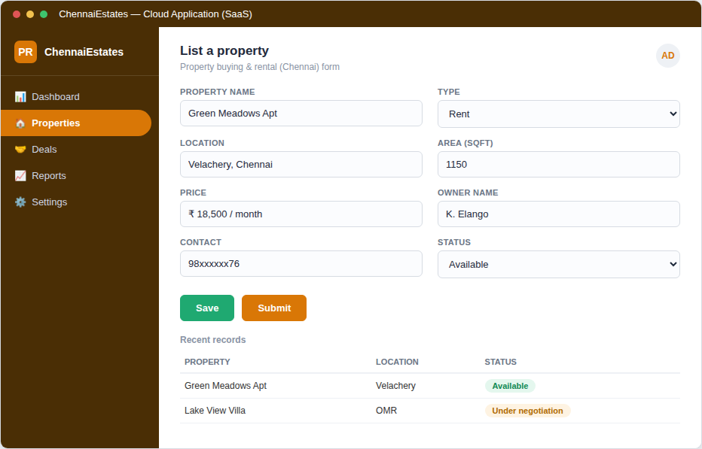
Figure 3: Property listing form and record list for the Chennai property application.
RESULT:
A cloud-based Property Buying & Rental application for Chennai city was successfully created. The application captured property, owner, and pricing details correctly and was accessible through a web browser, demonstrating the Software as a Service (SaaS) model.

